**New Dis- Eur-France-**Le Grand Pressigny-Neolithic-Straight Burin-2400 BCE-2000 BCE

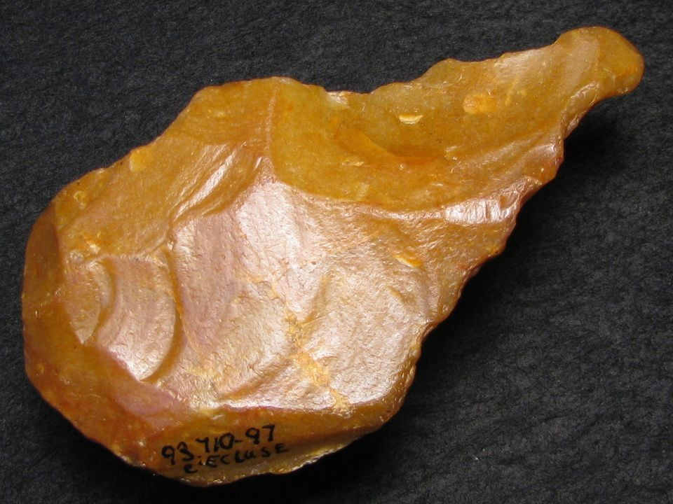

### **Formal Label: France-**Le Grand Pressigny-Neolithic-Straight Burin-2400 BCE-2000 BCE

**Accession Number:**

**LC Classification:** GN776.22.F7

**Date or Time Horizon:** 2400-2000 BCE

**Geographical Area:** Le Grand Pressigny, [46 ° 55 '19 "North](https://translate.googleusercontent.com/translate_c?depth=1&hl=en&prev=search&rurl=translate.google.com&sl=fr&sp=nmt4&u=http://tools.wmflabs.org/geohack/geohack.php%3Flanguage%3Dfr%26pagename%3DMus%25C3%25A9e_de_la_Pr%25C3%25A9histoire_du_Grand-Pressigny%26params%3D46.921809_N_0.803508_E_type:landmark_region:FR&usg=ALkJrhgTi55y0QOKYbuJSjEaIs86gAUBfA) [,](https://translate.googleusercontent.com/translate_c?depth=1&hl=en&prev=search&rurl=translate.google.com&sl=fr&sp=nmt4&u=http://tools.wmflabs.org/geohack/geohack.php%3Flanguage%3Dfr%26pagename%3DMus%25C3%25A9e_de_la_Pr%25C3%25A9histoire_du_Grand-Pressigny%26params%3D46.921809_N_0.803508_E_type:landmark_region:FR&usg=ALkJrhgTi55y0QOKYbuJSjEaIs86gAUBfA) [0 ° 48 '13 "](https://translate.googleusercontent.com/translate_c?depth=1&hl=en&prev=search&rurl=translate.google.com&sl=fr&sp=nmt4&u=http://tools.wmflabs.org/geohack/geohack.php%3Flanguage%3Dfr%26pagename%3DMus%25C3%25A9e_de_la_Pr%25C3%25A9histoire_du_Grand-Pressigny%26params%3D46.921809_N_0.803508_E_type:landmark_region:FR&usg=ALkJrhgTi55y0QOKYbuJSjEaIs86gAUBfA)

**Cultural Affiliation:** French Neolithic

**Medium:** Le Grand Pressigny Flint

**Dimensions:   
Weight:**

**Provenance: from an** old Le Grand Pressigny collection.

**Condition:** original

**Discussion:**

Le Grand Pressigny is the eponymous name of a Neolithic flint industry known since 1863 for its blades, which are expertly flaked from a "butter pound" shaped core.

This straight burin is an example of a tool made by striking the core, and then manipulating the flake with a large, deep facette struck on its edge to produce the burin.

**References:**

Louboutin, C. 2011. Archeology of the Touraine. Éditions La Simarre

Mallet, Nicole. 1992. *Grand-Pressigny: ses relations avec la civilisation Saône-Rhône*. [Argenton-sur-Creuse?]: Amis du Musée de préhistoire du Grand-Pressigny. v.1. Texte -- v. 2. Planches.

Steenstrup, J. and John Lubbock. 1867. “On the Flint Implements Recently Discovered at Pressigny-le-Grand,” *Transactions of the Ethnological Society of London*, 5: 221-227.